Allow Less Secure Apps Option Gmail

Step 1

Login into your Google Account

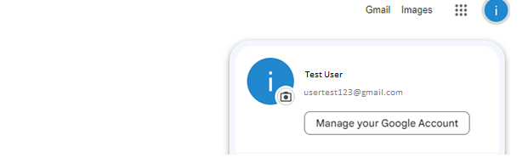

Click on Manage Your Google Account

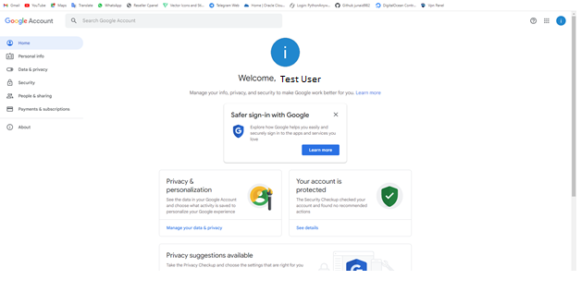

This page will Appear

Step 2

Click on Security option present left side of screen

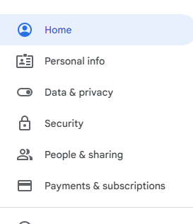

This page will appear

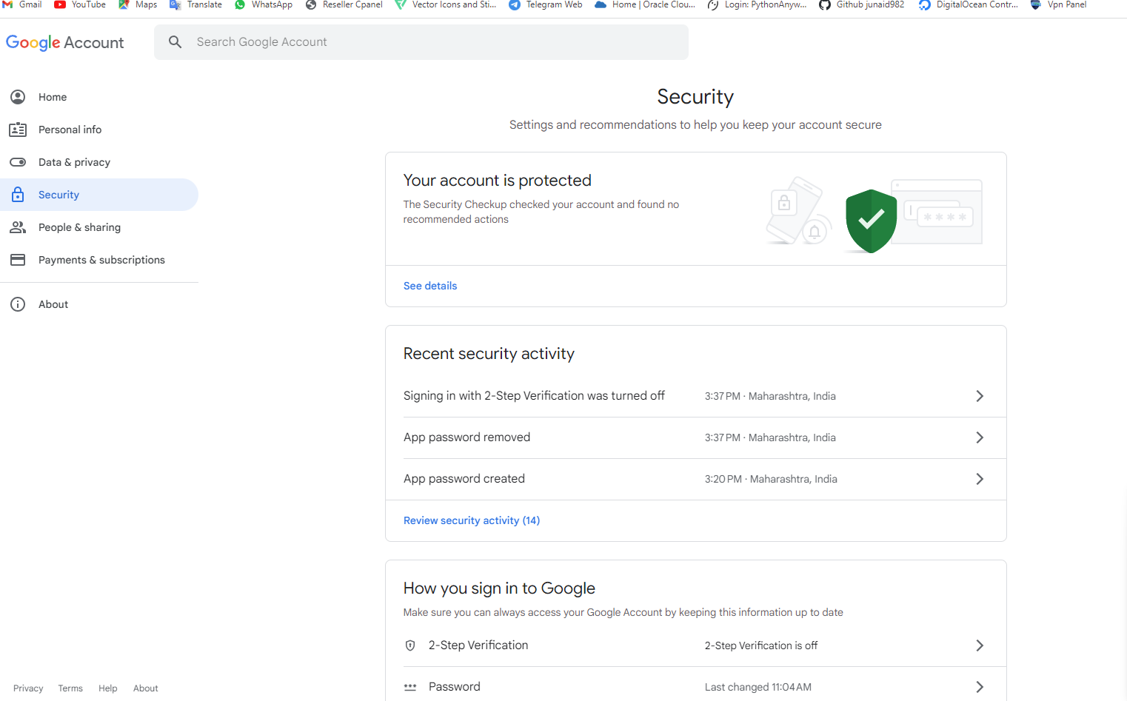

Scroll down and find

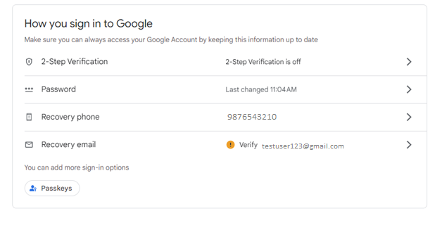

Step 3

We have to allow 2 step verification

Click on if its off

2-Step Varification options

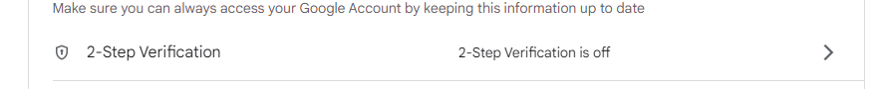

This page will appear

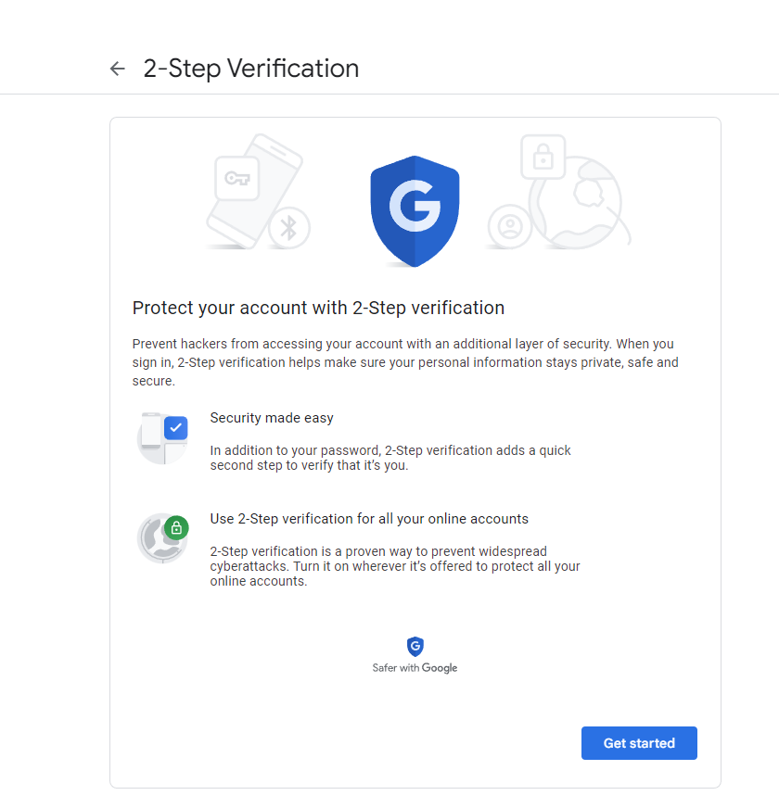

Click on Get Started Option

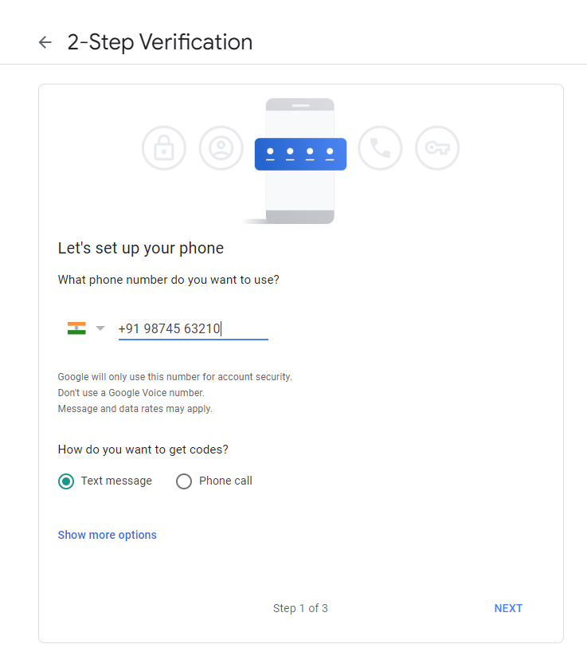

Enter your contact Number and select Text message

And confirm with your verification code

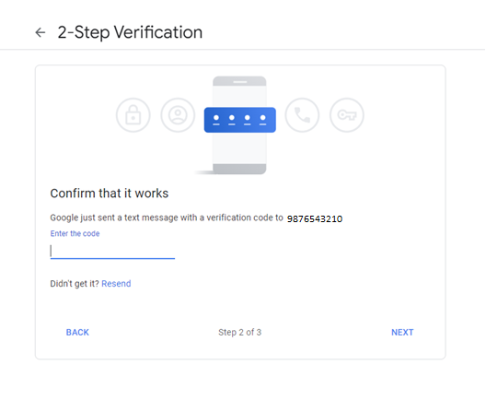

Next

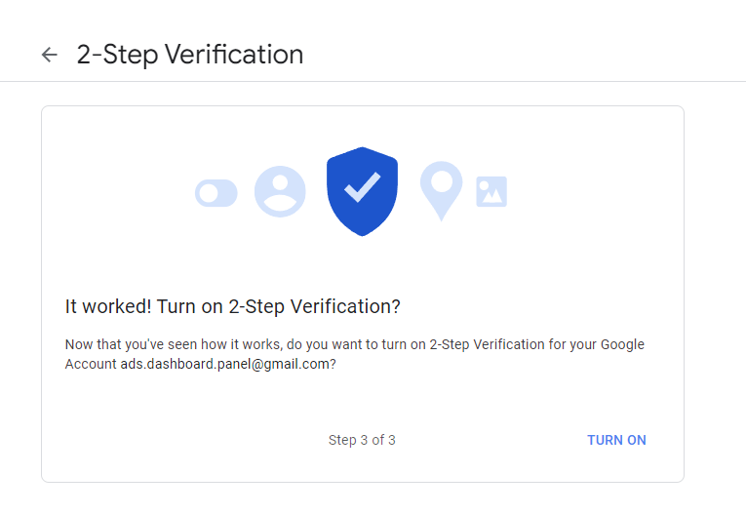

Click **TURN ON** Two-Step Varification on

Step 4

This page will appear

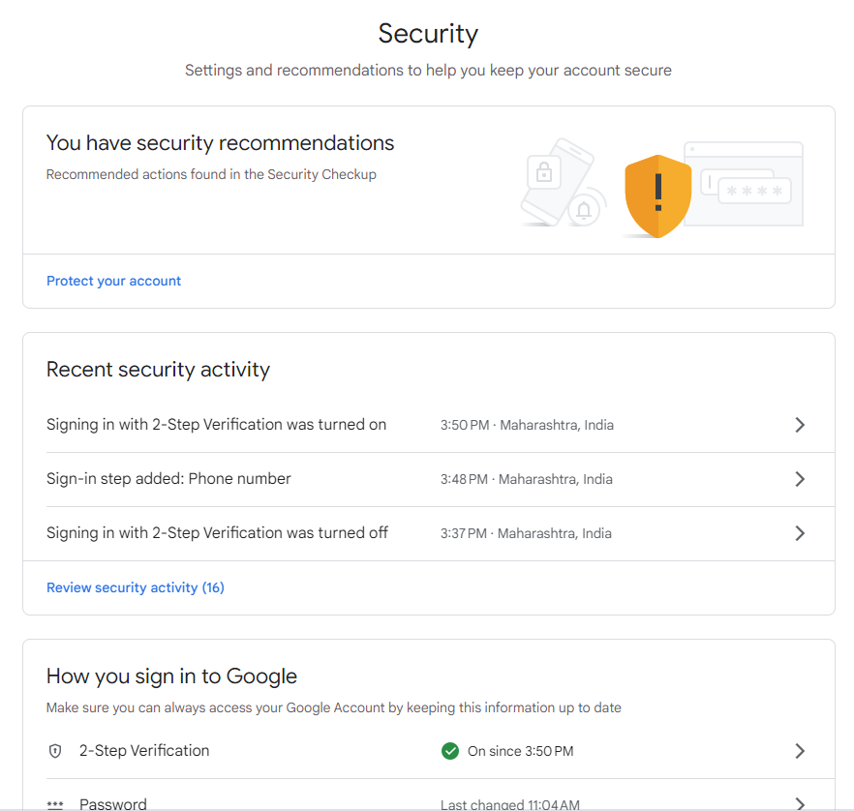

Find This option below

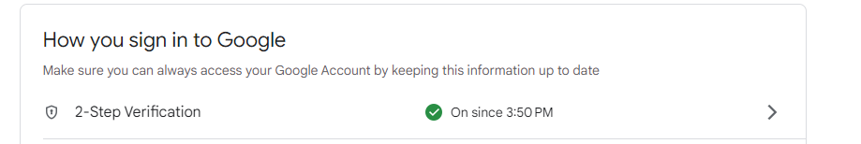

And click into it

This page will appear

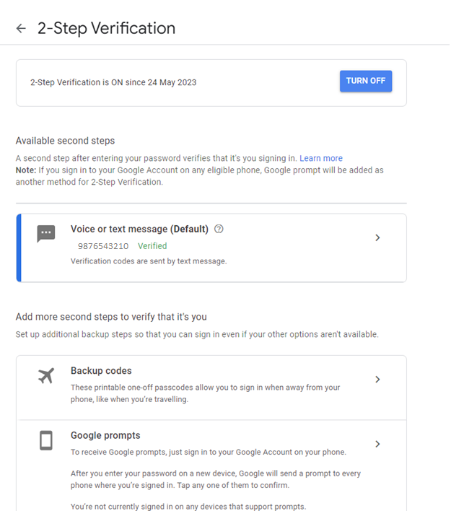

Scroll down and you can find this option

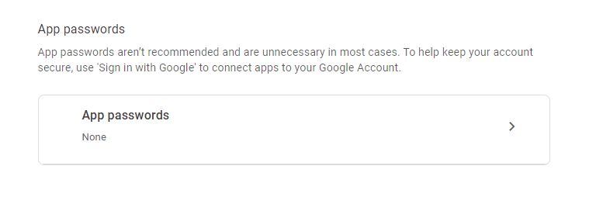

Click on App Password

After that this page will appear

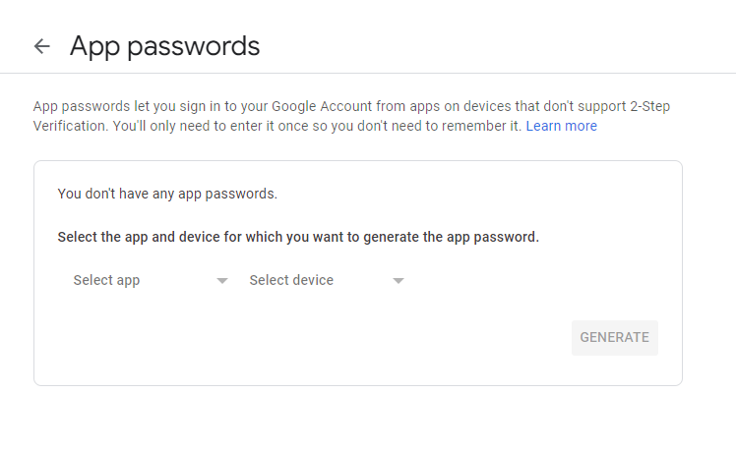

Step 5

Generate password for mail

Select this

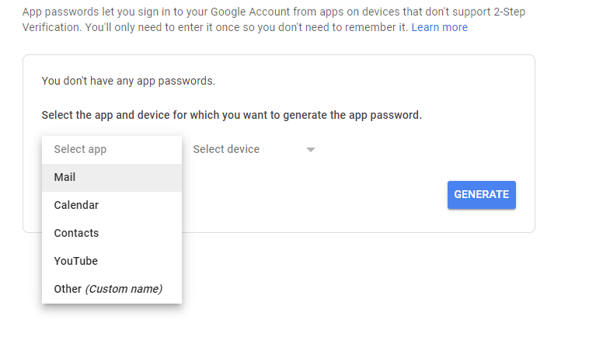

Then

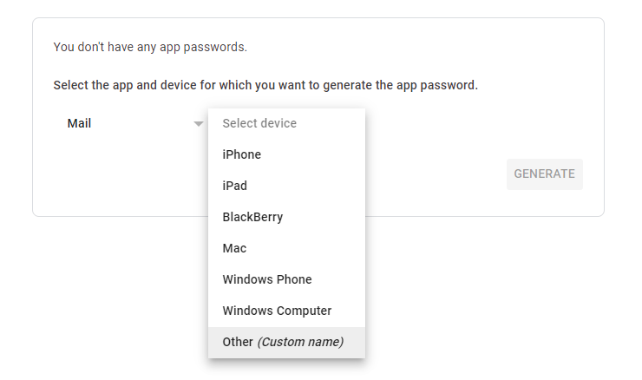

Then Write anything you want

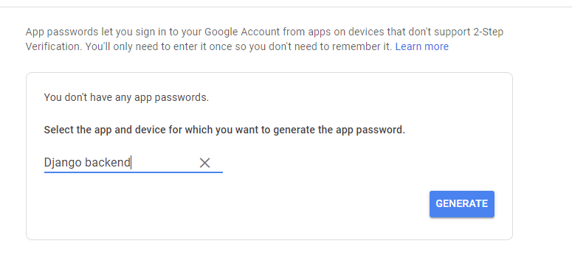

Then click GENERATE button

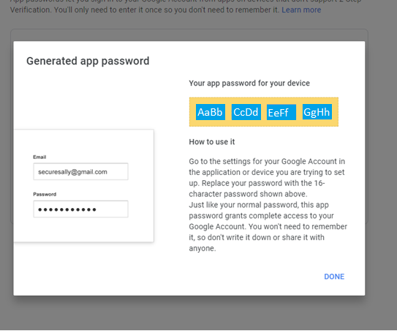

Now copy the password and use in your Django app